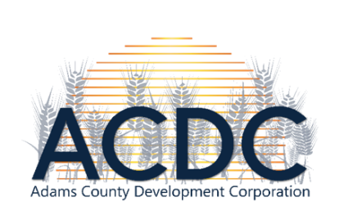

September 7th, 2022 Joint Board Meeting Agenda
The Rural Collective & Via Zoom

Call to Order & Declaration of Quorum: The meeting was called to order at 7:02pm.

Present: Jasmin Fosheim, Mikhayla Bliss
ACDC: Dorothy Becker, Trevor Wolff, Dusty Laufer, Kevin Pagel, Alex Thompson, Bruce Hagen, James Lindquist, Nicole Sott
Chamber: Kat Weinert, LeAnn Fitch, Alexis Hicks, Ted Uecker, Josh Raab, Pam Burch, Nicole Sott, Zoom: Jacki Christman

Joint Board Meeting:
Executive Director Transition: Due to the nature of the Executive Director position, both Hettinger Chamber of Commerce and Adams County Development Corporation met to discuss decisions moving forward regarding Jasmin Fosheim’s notice of resignation upon the arrival of her baby (due December 9th). The two boards brainstormed ideas pertaining a hiring committee and advertisement efforts. Moving forward, advertising for the Executive Director position will be taking place effective immediately, with a deadline of October 15th. The individuals who make the up the hiring committee are Kat Weinert, Jacki Christman, LeAnn Fitch, Dorothy Becker, James Lindquist, and Alex Thompson.

Once the boards narrowed down the direction for the next few months, the members broke out into their respective board committees to carry motions of approval for the advertisement of the joint Executive Director position.

Meeting adjourned: Trevor Wolff 2nd: Josh Raab

